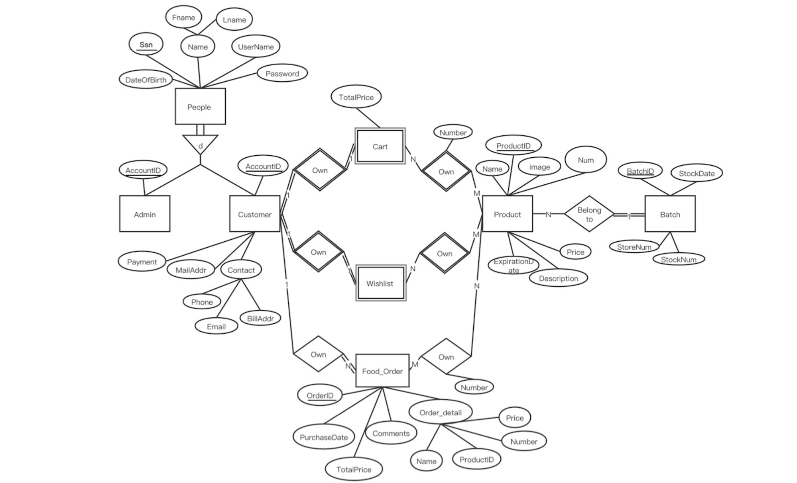

Fname

Lname

Ssn

Name

UserName

Password

DateOfBirth

TotalPrice

People

Number

Todt 830mg

Cart

ProductID

Num

AccountiD

AccountID

Own

Name

image

Own

BatchID

StockDate

Admin

Customer

Product

Belong

to

Batch

StoreNum

Own

Own

Price

Payment

Expiration

StockNum

MailAddr

Contact

ate

Description

Wishlist

Phone

BillAddr

Email

Own

Own

Food_Order

Number

OrderID

Order_detail

Price

Comments

Purchase Date

Number

Name

ProductID

TotalPrice